# 

**Your name**

# A

# Project Report On

# 

# Project Title

***Submitted By:***

**Your Name**

***In partial fulfilment for the award of the degree of***

## YOUR DEGREE NAME

***In***

## COMPUTER SCIENCE & ENGINEERING

**YOUR UNIVERSITY NAME**

DATE-YEAR

# STUDENT’S DECLARATION

We the students of VIII semester B.Tech. Your University Name____, ABC(your name) declare that he technical Project work entitled “**ONLINE SHOPPING SYSTEM”** has been carried out and submitted in the partial fulfilment of the course requirements for the award of degree in B.Tech. Computer Science Engineering at ________during the academic year 2023-24. The matter submitted in the synopsis has been not submitted to any other university or institutions for the award of any other degree or diploma in the concerned stream.

### Your name

**Place: Date:**

# CERTIFICATE

This is to certify that the dissertation report entitled, “Online Shopping System” submitted by your name , India, is a record of bonafide project work carried out by them under our supervision and guidance and is worthy of consideration for award of Degree of Bachelor of Technology in Computer Science Engineering of the Institute.

**Project Guide:** Mr. __________

Assistant Professor

Department Of Computer science Engineering

**Project Coordinator:** Mr. ___________

Assistant Professor

Department Of Computer science Engineering

**Head Of The Department:** _____________

HOD / Asst. Professor

Department Of Computer Science Engineering ____________

**INTRODUCTION**

Chapter 1

**1.1 ABOUT SYSTEM**

**1.2 PURPOSE**

**1.3 Technology and**

**Literature view**

Chapter 1

Project profile

**1**

**1.1ABOUT SYSTEM**

**ONLINE AUCTION** website is very friendly and also very light in terms of loading, it takes less time to load on browser because we used very less images on our website because in India and especially in our city speed of internet is very slow and more people are using internet through their mobile devices.

* The main feature of this website is our Online system, through which people Easy to Manage All Activity.

**1.2 PURPOSE**

The main purposes to develop this website is now a day’s people becoming more dependent on technology and understand the value of time so by using our online form & Other Activity Through system

**1.3TECHNOLOGICAL AND LITERATURE REVIEW**

**1.3.1 TECHNOLOGICAL REVIEW**

* **Introduction to ANGULAR AND SPRING BOOT :-**

ANGULAR AND SPRING BOOT is more than the next version of Active Server Pages (ANGULAR AND SPRING BOOT); it provides a unified Web development model that includes the services necessary for developers to build enterprise-class Web applications. While ANGULAR AND SPRING BOOT is largely syntax compatible with ANGULAR AND SPRING BOOT, it also provides a new programming model and infrastructure for more scalable and stable applications that help provide greater protection. You can feel free to augment your existing ANGULAR AND SPRING BOOT applications by incrementally adding ANGULAR AND SPRING BOOT functionality to them.

ANGULAR AND SPRING BOOT is a compiled, -based environment; you can author applications in any compatible language, including Visual Basic , C#, and JScript . Additionally, the entire Framework is available to any ANGULAR AND SPRING BOOT application. Developers can easily access the benefits of these technologies, which include the managed common language runtime environment, type safety, inheritance, and so on.

* **What is ANGULAR AND SPRING BOOT? :-**

ANGULAR AND SPRING BOOT stands for HYPER TEXT PREPROCESSER Pages and is developed by.ANGULAR AND SPRING BOOT is used to create web pages and web technologies and is an integral part of Microsoft's framework vision.

* As a member of the framework, ANGULAR AND SPRING BOOT is a very valuable tool for programmers and developers as it allows them to build dynamic, rich web sites and web applications using compiled languages like .
* ANGULAR AND SPRING BOOT is a web application framework developed and marketed by to allow programmers to build dynamic web sites, web applications & so on.
* ANGULAR AND SPRING BOOT is the next generation ANGULAR AND SPRING BOOT, but it is not an upgraded version of an ANGULAR AND SPRING BOOT. ANGULAR AND SPRING BOOT is an entirely new technology for server-side scripting.

***“ANGULAR AND SPRING BOOT is a server side scripting technology that enables scripts (embedded in web pages) to be executed by an Internet server.”***

* ANGULAR AND SPRING BOOT is a Open Source Technology
* ANGULAR AND SPRING BOOT stands for Hypertext Preprocesser
* ANGULAR AND SPRING BOOT is a program that runs inside Apache
* **New in ANGULAR AND SPRING BOOT :-**
* Better language support
* Programmable controls
* Event-driven programming
* XML-based components
* User authentication, with accounts and roles
* Higher scalability
* Increased performance - Compiled code
* Easier configuration and deployment.
* **Advantages of ANGULAR AND SPRING BOOT :-**
* SQL Server is also very fast, secure, and it can store extremely large amounts of data; actually, there’s no limit.
* With ANGULAR AND SPRING BOOT you get the whole Class Library and the thousands of third party components as well. There are definitely much more third party components out there for than for ANGULAR AND SPRING BOOT.
* In ANGULAR AND SPRING BOOT it’s easy to use threads and builds asynchronous handlers in your server-side web code.
* With built-in Windows authentication and per-application configuration, your applications are safe and secured.
* It provides better performance by taking advantage of early binding, just-in-time compilation, native optimization, and caching services right out of the box.
* **Front End: ANGULAR AND SPRING BOOT :-**

ANGULAR AND SPRING BOOT, which is the version of ANGULAR AND SPRING BOOT, is built on the Microsoft Framework. Microsoft introduced the Framework to help developers create globally distributed software with Internet functionality and interoperability.

ANGULAR AND SPRING BOOT has been developed to work seamlessly with HTML editors and other programming tools; including Microsoft Visual Studio . Not only does this make Web development easier, but it also provides all the benefits that these tools have to offer. Also its code-behind feature allows designing not to be interfered with coding. This helps in systematic approach to the application.

* **Back End: My SQL :-**

Microsoft and Sybase termed up to create sql server. It run only IBM’S os/2 operating system platform. After relapse of version 6.5 Microsoft and Sybase separate and sql server made its progress into the competitive markets server 6.5 the earlier version mainly focused on database design and implementation .the latest version (7.0) is signification release of sql server.

SQL made is an SQL complainant means it uses the ANSI version of structured query language is database.

Client server means that SQL server designed to store data in the central location and deliver it on demand to numerous other locations.

* **Advantages :-**
* To hide data complexity.
* To protect the data.
* Enforcing some simple business rules.
* Customizing data.
* Enterprise-Grade management software.
* Excellent data recovery.
* Better performance features.
* Better security features.
* Lower Ownership costs.
* **Features :-**
* Programmability
* Manageability
* Basic Data Integration
* Basic High Availability
* Advanced Security
* Advanced data integration
* Advanced High arability

**PROJECT DEVELOPMENT APPROACH**

as Gantt charts to plan and subsequently report progress within the project environment.

Initially, the project scope is defined and the appropriate methods for completing the project are determined. Following this step, the durations for the various tasks necessary to complete the work are listed and grouped into a work breakdown structure. The logical dependencies between tasks are defined using an activity network diagram that enables identification of the critical path. Float or slack time in the schedule can be calculated using project management software. Then the necessary resources can be estimated and costs for each activity can be allocated to each resource, giving the total project cost. At this stage, the project plan may be

optimized to achieve the appropriate balance between resource usage and project duration to comply with the project objectives. Once established and agreed, the plan becomes what is known as the baseline. Progress will be measured against the baseline throughout the life of

the project. Analyzing progress compared to the baseline is known as earned value management.

A **software development process**, also known as a **software development life cycle (**

**SDLC)**, is a structure imposed on the development of a software product. Similar terms include software life cycle and software process. It is often considered a subset of systems development life cycle. There are several models for such processes, each describeing approaches to a variety of tasks or activities that take place during the process. Some people consider a lifecycle model a more general term and a software development process a more specific term. For example, there are many specific software development processes that 'fit' the spiral lifecycle model. ISO 12207 is an ISO standard for software lifecycle processes. It aims to be the standard that defines all the

tasks required for developing and maintaining software.

The **waterfall model** is a sequential design process, often used in software development processes, in which progress is seen as flowing steadily downwards (like a waterfall) through the phases of Conception, Initiation, Analysis, Design,Construction, Testing,Implementation, and maintenance.The waterfall development model originates inthe manufacturing and construction industries; highly structured physical environments in which after-the-fact changes are prohibitively costly, if not impossible. Since no formal software development methodologies existed at the time, this hardware-oriented model was simply adapted for software development.

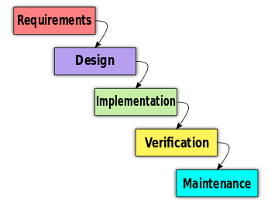

**Waterfall Model**

**Project plan**

The objective of project planning is to provide a framework that enables the manager to make reasonable estimates of resources, cost and schedule.

* Identify objectives
* Determine information requirements
* Analyze System Needs
* Designing
* Development
* Testing
* Deployment
* **MILESTONES AND DELIVERABLES:-**

Managers need information. As software is intangible, this information can only be provided as document that describes the state of the software being developed. Without this information, it is important to judge progress and cost estimates and schedules cannot be updated.

When planning, a project a series of milestones should be established where a milestone is an end-point of a software process activity. At each milestone, there should be a formal output, such as a report, they can be represented to management. Milestone reports don't need large documents. They may simply be a short report of achievements in a project activity. Milestones should represent the end of a distinct, logical stage in the project.

While milestones are unique to each project, some example project milestones are shown below:

* Requirements Approval
* Phase Review Approval
* Prototype Approval
* Design Reviews Complete
* Code Reviews Complete
* Unit Test Complete
* Integration Test Complete
* Acceptance Test Complete
* System Acceptance by User
* Customer Shipment
* Documentation Delivery

A "deliverable" is a project result that is delivered to the customer. It is usually delivered at the end of some major project phase such as specification, design, etc. Deliverables are usually milestones but milestones need not to be deliverables. Milestones may be internal project results that are used by the major project manager to check project progress but which are not delivered to the customers. To establish milestones, the software process must be broken down into basic activities with associated outputs.

* **Deliverables responsibilities:-**

Because this is a deliverables-based project, we have created two additional responsibilities: primary owner and secondary owner. These responsibilities are associated with either an artifact or a process.

* **Primary:-**

The responsibility of primary owner combines the responsibilities of planning, implementing, and monitoring. In addition, the responsibility includes assuring that the necessary quality, change, and risk processes are applied to the artifact or process.

* **Secondary:-**

The responsibility of secondary owner usually applies to project processes. For example, the change management process can have a primary owner who initiated, planned, and implemented the process. The responsibility of the secondary owner is monitoring and controlling. Additional responsibilities include holding meetings as required by the process, maintaining logs, and facilitating decisions.

**SCHEDULE REPRESENTATION**

The project scheduling provides graphical representation of predict tasks, milestones, dependencies, resource requirements, task duration and deadlines.

Like the development of each of the project plan components, developing a schedule is an iterative process. Milestones may suggest additional tasks, tasks may require additional resources, and task completion may be measured by additional milestones. For large, complex projects, detailed sub-schedules may be required to show an adequate level of detail for each task.

During the life of the project, actual progress is frequently compared with the original schedule. This allows for evaluation of development activities. The accuracy of the planning process can also be assessed.

Basic efforts associated with developing a project schedule include the following:

* **Define the type of schedule:-**

The type of schedule associated with a project relates to the complexity of the implementation. For large, complex projects with a multitude of interrelated tasks, a PERT chart (or activity network) may be used.

* **Define precise and measurable milestones:-**

The completion of key actions is important in all projects. These completions are denoted by milestones. These events have no duration. For example, deliverables often are represented as milestones, while the effort to produce the deliverable is referred to as a task.

* **Estimate task duration:-**

Estimating task duration is one of the most challenging ANGULAR AND SPRING BOOTects of projectplanning. It is also a key to later cost estimation. This is a refined process that occurs throughout the planning process, as it is directly affected by results of the staffing and costing activities.

* **Define priorities:-**

Clearly defining the task properties helps to resolve any scheduling resource conflicts. Understanding the priorities and relationship of the tasks assists in resolving difficult conflicts.

* **Define the critical path:-**

The critical path is the longest path through a project. It determines the earliest possible completion of the work. The critical path is carefully managed because if critical path tasks slip, the entire project is delayed. In order to manage the project, the project manager determines the critical path and remains aware of its importance throughout the implementation of the plan.

* **Document assumptions:-**

Documentation of the assumptions made in developing the project schedule are critical to the later success of the project. Without clear documentation of these assumptions, later changes to the schedule are very difficult and risky.

**System**

**requirements study**

Chapter 2

* 1. **User characteristics**
  2. **Hardware & software**

**requirements**

Chapter 1

Project Profile

**2.1 USER CHARACTERISTICS**

* **Candidate module :-**

The candidate will logon to the software and take his examination. He can also check his previous examinations marks and his details. The candidate will get result immediately after the completion of the examination

* **Examiner module**

The database is prepared & loaded into the software. Selection for examination can be done language wise by the examiner. The results will be displayed immediately after completion of the examination.

* **Administrator module**

The administrator collects all the results after successful completion of the examination and sends to the head quarters as and when required

**The features that are available to the Administrator are:**

* The administrator has the full fledged rights over the OES.
* Can create/delete an account.
* Can view the accounts.
* Can change the password.
* Can hide any kind of features from the both of users.
* Insert/delete/edit the information of available on OES.

Can access all the accounts of the faculty members/students

**The features available to the Students are:**

* Can view the different categories of Test available in their account.
* Can change password.
* Can view their marks.
* Can view the various reading material.
* Can view and modify its profile but can modify it to some limited range.

**The features available to the Examiner are:**

* Can view the different categories of Test conducted by users.
* Can change password.
* Can view their marks.
* Can view and modify Results.

**2.2 HARDWARE AND SOFTWARE REQUIREMENTS**

|  |  |
| --- | --- |
| Project Title | Madica Hospital |
| Minimum Hardware  Requirements | Pentium-IV  512 MB RAM  10GB Hard disk Space |
| Operating System | Windows XP/2003/7/8/8.1/10 or Linux |
| Front End tool | ANGULAR AND SPRING BOOT |
| Back End Tool | MySQL |
| Documentation | Microsoft Word 2007 / 2003/2010/2013 |

**Table 2.1 Hardware and Software requirements**

ting Planning involves how to plan testing before we are going to start making test suite .First step of testing is to test the System Module by Module that is once the module has been completed we test the module.

Then in second step I have tested all the modules by merging them one by one that are first module is checked then second module is merged with that module and both modules are checked together.

For this I have used both white box testing and black box testing. In white box testing structural testing is done so all the modules are tested one by one and finally when the project is completed black box testing is used to test the whole system together.

**Componenets of structured analysis**

Chapter 3

* **Data flow diagram**
* **Process specification**
* **Control specification**
* **Entity relationship**

**Diagram**

* **Data dictionary**

**DATA FLOW DIAGRAM**

A Data flow diagram (DFD) is used to express system requirements in a graphical form. It is also known as a bubble chart. A DFD depicts information flow and transform that are applied as data moves from input. Use of DFD helps to clarify the system requirements. DFD are drawn surging analysis and are the starting point for the design phase. A DFD could be used represent a physical system, at the beginning of analysis, or a logical system at alter point in the system development life cycle. Being graphical, it is easy to understand.

A DFD is used to describe what data flows rather how if flows. The concern is understanding the transforms that are required that are required to convert the input to output. It is independent of hardware, software, data structure and file organization.

CONTEXT FREE DIAGRAM

User

Bid Management

Auction Management

LEVEL --1 DFD

Vendor

Username master

User details

User

Auction master

Auction master

Auction Details

Auction Type

Bid master

Bid Master

Bid Details

paymentmaster

payment_details

LEVEL --2 DFD

Username master

Accept

Checks User Details

Checks Access

Vendor

User

Customer

Store

Username Master & User Details

User

Visible Auction Master

Access

Interact

Auction Type

Retrieve

Auction Master & Auction Details

Customer

Bid Master

VISIBLE

INTERACT

Put

Bid Master & Details

Check

Is valid is not valid

Is direct is not direact

Payment details

**ENTITY RELATIONSHIP - DIGRAM**

An E R diagram is a model that identifies the concept or entities that exist in a system and the relationships between those entities. An ERD is often used as a way to visualize a relational database: each entity represents a database table and the relationship lines represents the key in one table that point to specific records in related tables.

Advantages of ER diagram

* Professional and faster Development.
* Productivity Improvement.
* Fewer Faults in Development.
* Maintenance becomes easy.

have

have detail

Auction management

Interact

Interact

Bid management

Interact

User management

Auction Type

Interact

1 m 1

1 1 1

M 1

Have details

m 1

Closing History

1 1 1

* Data Dictionary

|  |  |  |  |  |  |
| --- | --- | --- | --- | --- | --- |
| **Table Name:-reg** | | | | | |
| **Sr.No.** | **Name** | **Data Type** | **Size** | **Constraint** | **Description** |
| **1** | **Id** | **Int** | **10** | **PK** | **Id** |
| **2** | **username** | **Varchar** | **50** | **Not Null** | **user Type** |
| **3** | **password** | **Varchar** | **10** | **Not Null** | **password** |
| **4** | **Confpass** | **Varchar** | **10** | **Not Null** | **Confpass** |
| **5** | **Emailed** | **Varchar** | **30** | **Not Null** | **Emailed** |
| **6** | **Mobile** | **Varchar** | **12** | **Not Null** | **Mobile** |
| **7** | **Accountno** | **Varchar** | **10** | **Not Null** | **Accountno** |
| **8** | **Bankname** | **Varchar** | **30** | **Not Null** | **Bankname** |
| **9** | **Usertype** | **Varchar** | **25** | **Not Null** | **Usertype** |
| **10** | **Squsestion** | **Varchar** | **50** | **Not Null** | **squsestion** |
| **11** | **Ans** | **Varchar** | **50** | **Not Null** | **Ans** |
| **12** | **Address** | **Varchar** | **100** | **Not Null** | **Address** |
| **13** | **City** | **Varchar** | **20** | **Not Null** | **City** |
| **14** | **State** | **Varchar** | **20** | **Not Null** | **State** |
| **15** | **Country** | **Varchar** | **20** | **Not Null** | **Country** |

|  |  |  |  |  |  |
| --- | --- | --- | --- | --- | --- |
| **Table Name:-login** | | | | | |
| **Sr.No.** | **Name** | **Data Type** | **Size** | **Constraint** | **Description** |
| **1** | **Id** | **Int** | **10** | **PK** | **Id** |
| **2** | **Username** | **Varchar** | **50** | **Not Null** | **Username** |
| **3** | **Password** | **Varchar** | **10** | **Not Null** | **Password** |

|  |  |  |  |  |  |
| --- | --- | --- | --- | --- | --- |
| **Table Name:-passrecover** | | | | | |
| **Sr.No.** | **Name** | **Data Type** | **Size** | **Constraint** | **Description** |
| **1** | **Id** | **Int** | **10** | **PK** | **Id** |
| **2** | **squsestion** | **Varchar** | **50** | **Not Null** | **Squsestion** |
| **3** | **Ans** | **Varchar** | **30** | **Not Null** | **Ans** |

|  |  |  |  |  |  |
| --- | --- | --- | --- | --- | --- |
| **Table Name:-contact** | | | | | |
| **Sr.No.** | **Name** | **Data Type** | **Size** | **Constraint** | **Description** |
| **1** | **Id** | **Int** | **10** | **PK** | **Id** |
| **2** | **username** | **Varchar** | **50** | **Not Null** | **username** |
| **3** | **emailid** | **Varchar** | **30** | **Not Null** | **Emaileid** |
| **4** | **Mobile** | **Varchar** | **12** | **Not null** | **Mobile** |
| **5** | **description** | **Varchar** | **50** | **Not null** | **Description** |

|  |  |  |  |  |  |
| --- | --- | --- | --- | --- | --- |
| **Table Name:-freedback** | | | | | |
| **Sr.No.** | **Name** | **Data Type** | **Size** | **Constraint** | **Description** |
| **1** | **Id** | **Int** | **10** | **PK** | **Id** |
| **2** | **Username** | **Varchar** | **50** | **Not Null** | **username** |
| **3** | **Emailed** | **Varchar** | **30** | **Not Null** | **Emaileid** |
| **4** | **sub** | **Varchar** | **12** | **Not null** | **sub** |
| **5** | **freedback** | **Varchar** | **100** | **Not null** | **freedback** |

|  |  |  |  |  |  |
| --- | --- | --- | --- | --- | --- |
| **Table Name:-addauction** | | | | | |
| **Sr.No.** | **Name** | **Data Type** | **Size** | **Constraint** | **Description** |
| **1** | **Id** | **Int** | **10** | **PK** | **Id** |
| **2** | **typename** | **Varchar** | **50** | **Not Null** | **Typename** |
| **3** | **Typeimage** | **Varchar** | **30** | **Not Null** | **typeimage** |
| **4** | **itemname** | **Varchar** | **12** | **Not null** | **Itemname** |
| **5** | **itemtype** | **Varchar** | **100** | **Not null** | **Itemtype** |
| **5** | **itemimage** | **Varchar** | **10** | **Not null** | **Itemimage** |

|  |  |  |  |  |  |
| --- | --- | --- | --- | --- | --- |
| **Table Name:-addauction** | | | | | |
| **Sr.No.** | **Name** | **Data Type** | **Size** | **Constraint** | **Description** |
| **1** | **Id** | **Int** | **10** | **PK** | **Id** |
| **2** | **Username** | **Varchar** | **50** | **Not Null** | **username** |
| **3** | **Emailed** | **Varchar** | **30** | **Not Null** | **Emailed** |
| **4** | **Accountno** | **Varchar** | **12** | **Not null** | **Accounno** |
| **5** | **Bankname** | **Varchar** | **150** | **Not null** | **Bankname** |
| **5** | **Address** | **Varchar** | **100** | **Not null** | **Address** |
| **6** | **City** | **Varchar** | **50** | **Not null** | **City** |
| **7** | **State** | **Varchar** | **50** | **Not null** | **State** |
| **8** | **Country** | **Varchar** | **50** | **Not null** | **country** |

|  |  |  |  |  |  |
| --- | --- | --- | --- | --- | --- |
| **Table Name:-debitcard** | | | | | |
| **Sr.No.** | **Name** | **Data Type** | **Size** | **Constraint** | **Description** |
| **1** | **Id** | **Int** | **10** | **PK** | **Id** |
| **2** | **Bankname** | **Varchar** | **50** | **Not Null** | **Bankname** |
| **4** | **Accountno** | **Varchar** | **12** | **Not null** | **Accounno** |
| **5** | **Cheqno** | **Varchar** | **50** | **Not null** | **Cheqno** |
| **5** | **Amount** | **Varchar** | **100** | **Not null** | **Amount** |
| **6** | **Address** | **Varchar** | **50** | **Not null** | **Address** |
| **7** | **Date** | **Date** | **50** | **Not null** | **Date** |

|  |  |  |  |  |  |
| --- | --- | --- | --- | --- | --- |
| **Table Name:-creditcard** | | | | | |
| **Sr.No.** | **Name** | **Data Type** | **Size** | **Constraint** | **Description** |
| **1** | **Id** | **Int** | **10** | **PK** | **Id** |
| **2** | **bankname** | **Varchar** | **50** | **Not Null** | **Bankname** |
| **4** | **Accountno** | **Varchar** | **12** | **Not null** | **Accounno** |
| **5** | **creditno** | **Varchar** | **50** | **Not null** | **Cheqno** |
| **5** | **payamount** | **Varchar** | **10** | **Not null** | **payAmount** |
| **6** | **Address** | **Varchar** | **100** | **Not null** | **Address** |
| **7** | **Date** | **Date** | **50** | **Not null** | **Date** |

**SCREENSHOTS**

Chapter 4

* **Home page**
* **Registering**
* **Contact us**
* **Vander ac**
* **Feedback**
* **Add items**
* **Add auction details**
* **Credit/debit card**

**HOME PAGE :-**



**SCRIPTION:-**

Our Online Auction information to see all the information on homepage**.**

**Register :-**

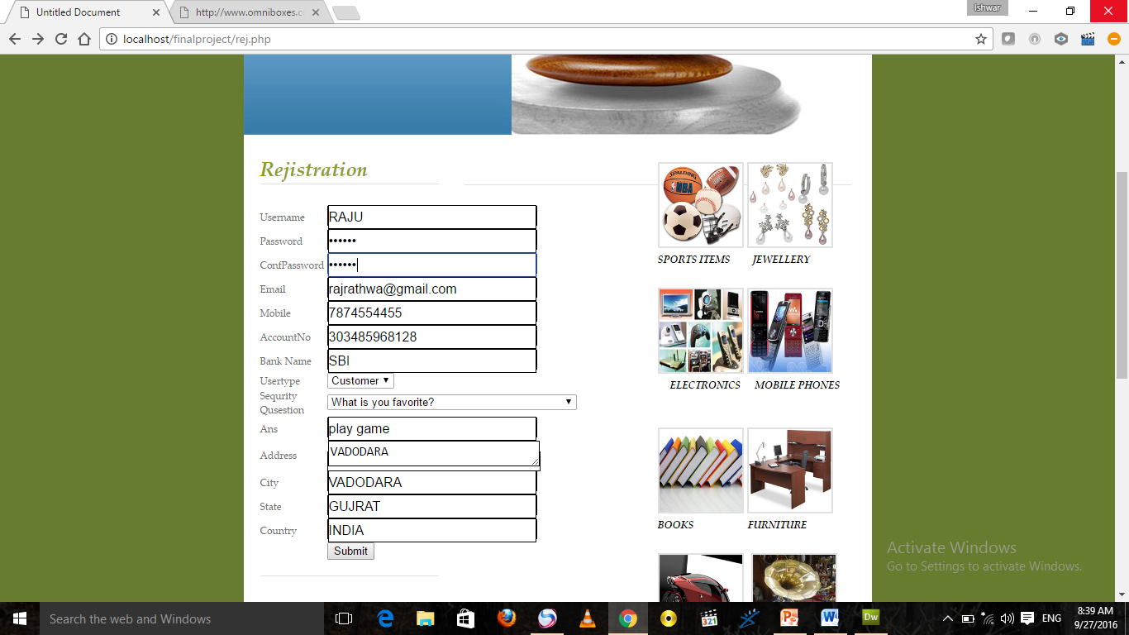

**DESCRIPTION:-**

Our User registration page.

**Login:-**

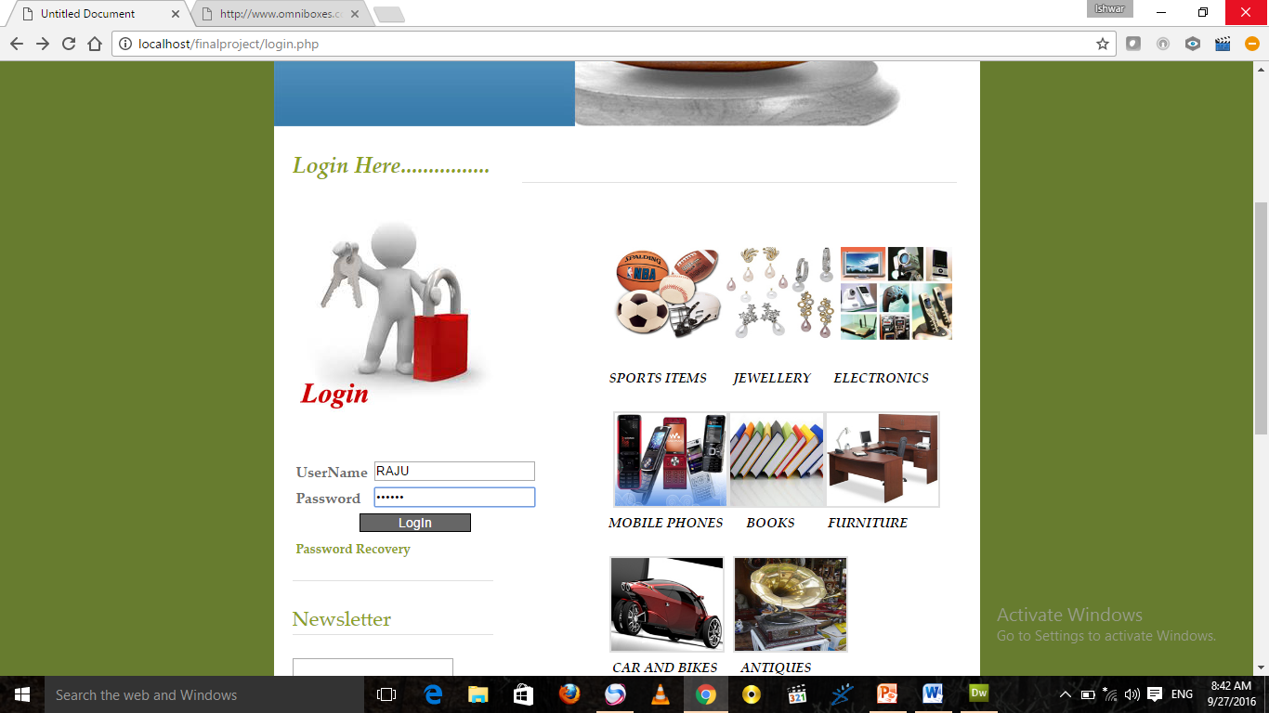

**DESCRIPTION:-**

Our Online Auction login detail display on login page.

**Edit:**

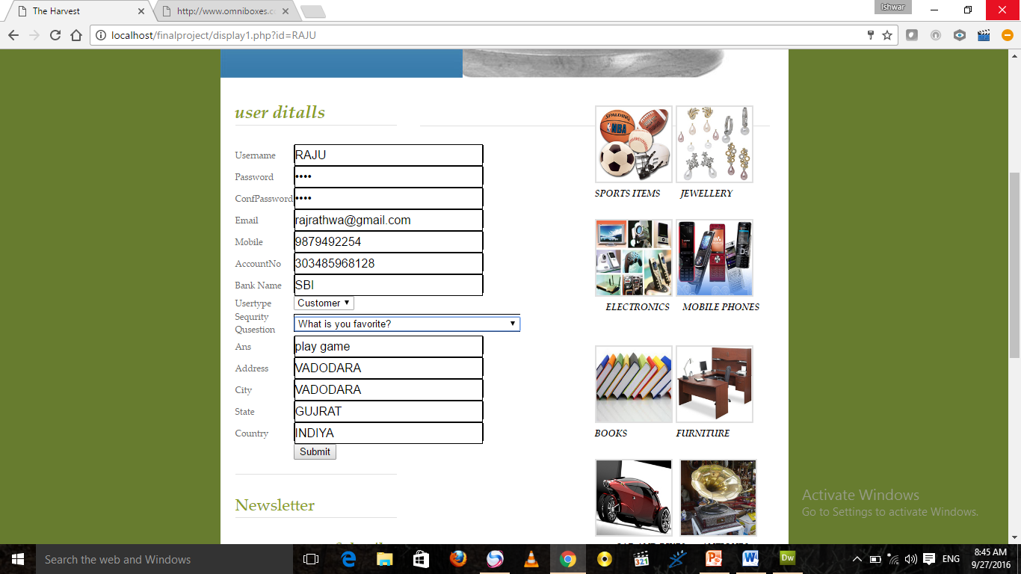

**DESCRIPTION:-**

User Distells And Edit display on Edit page.

**Password Recovery**

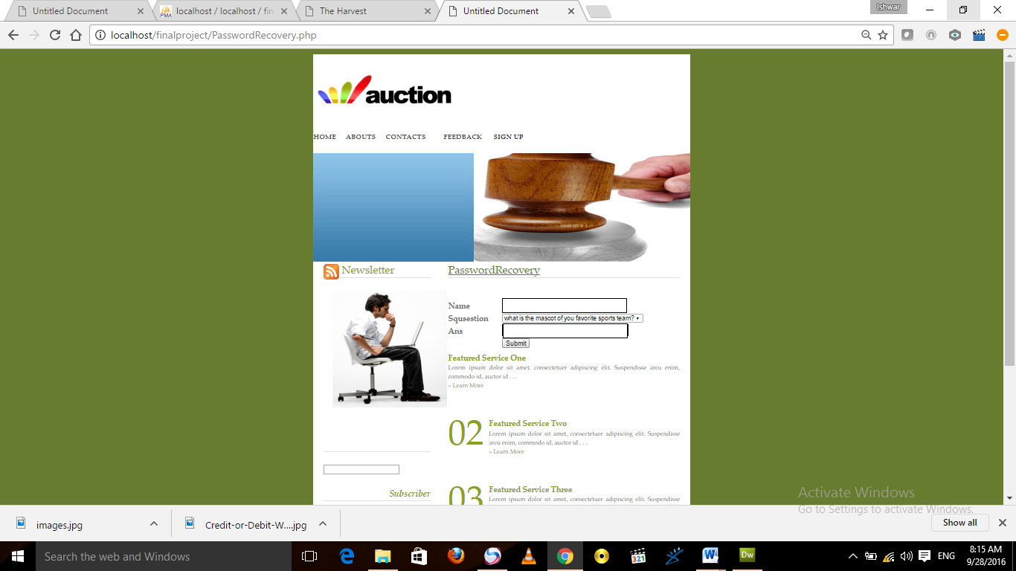

**DESCRIPTION:-**

User Online Auction password Recovery page.

**Abouts us:-**

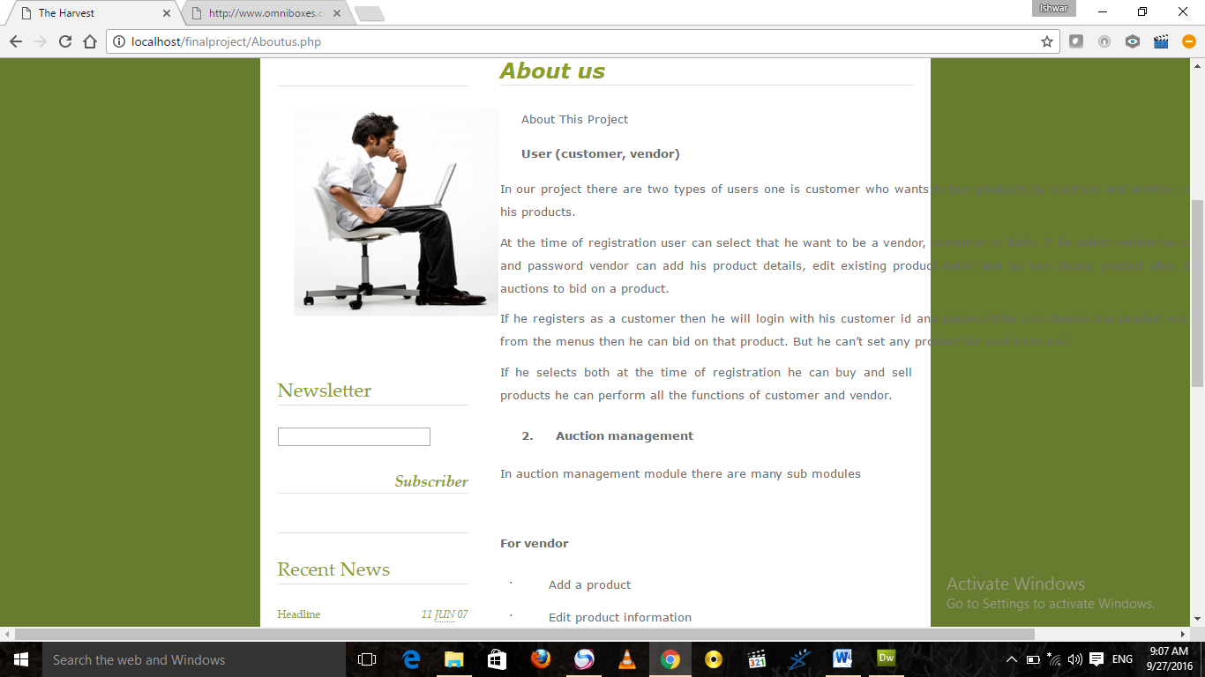

**Contact Us:-**

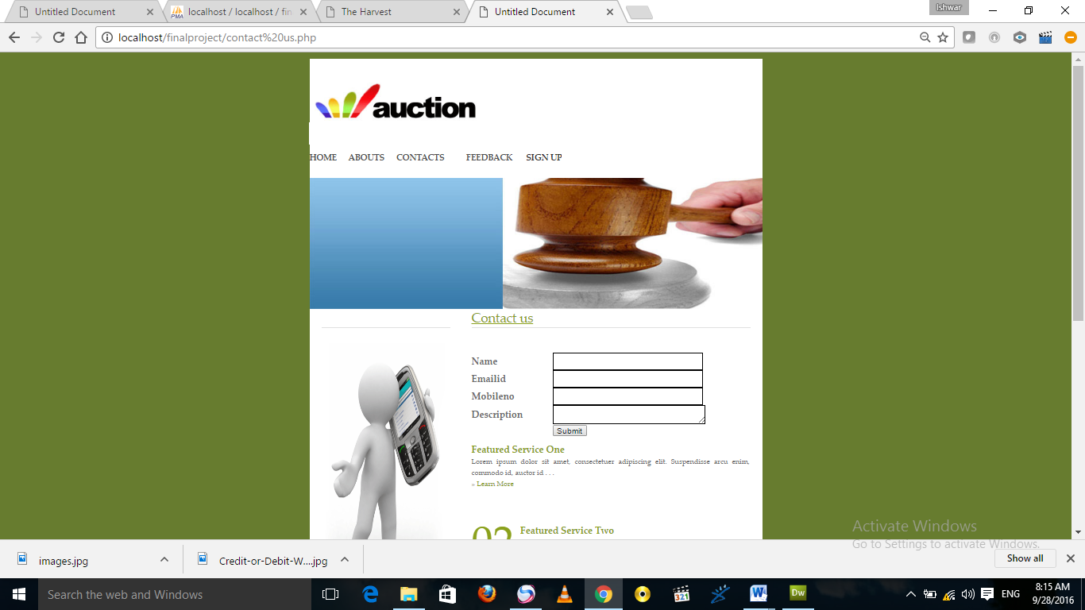

**Feedback:-**

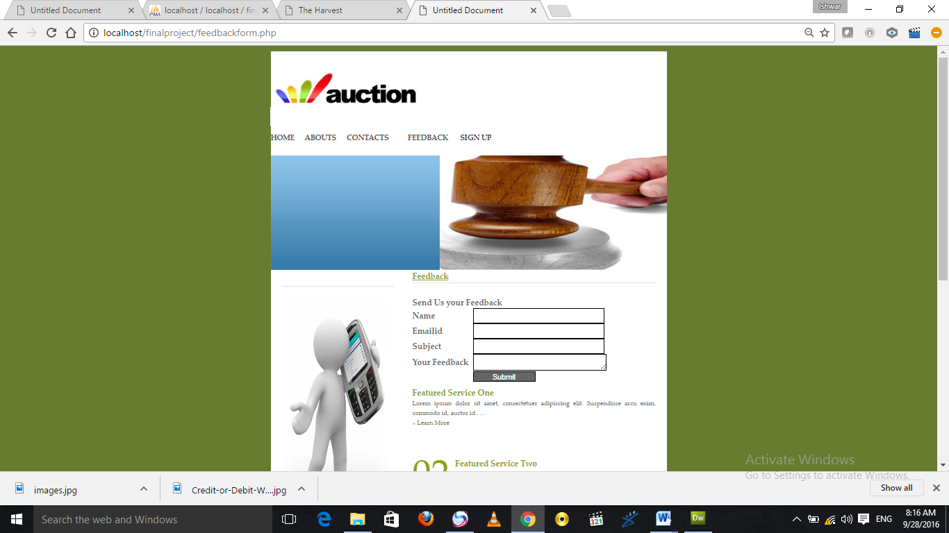

**DESCRIPTION:-**

Our Online Auction User feedback detail enter feedback page.

**Vender Account:-**

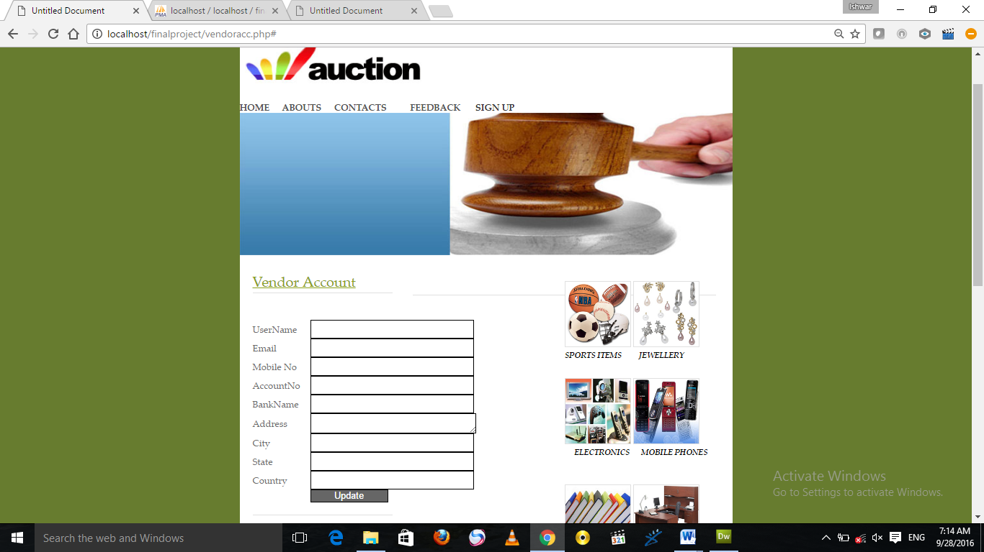

**DESCRIPTION:-**

Our Vender Account detail display on Admin display page.

**Debit Card:-**

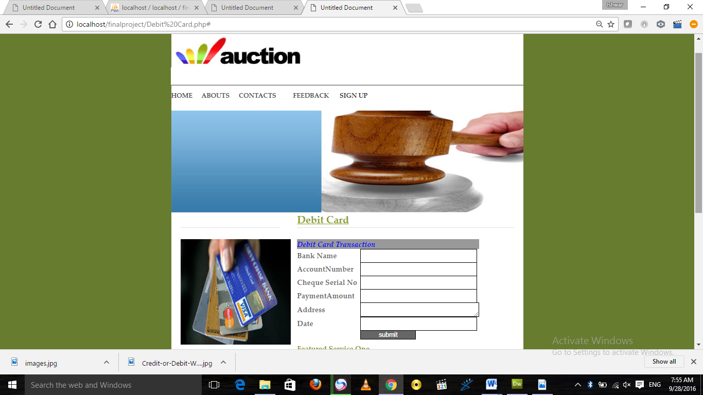

**DESCRIPTION:-**

Our user payment detail display .

**Crebit Card:-**

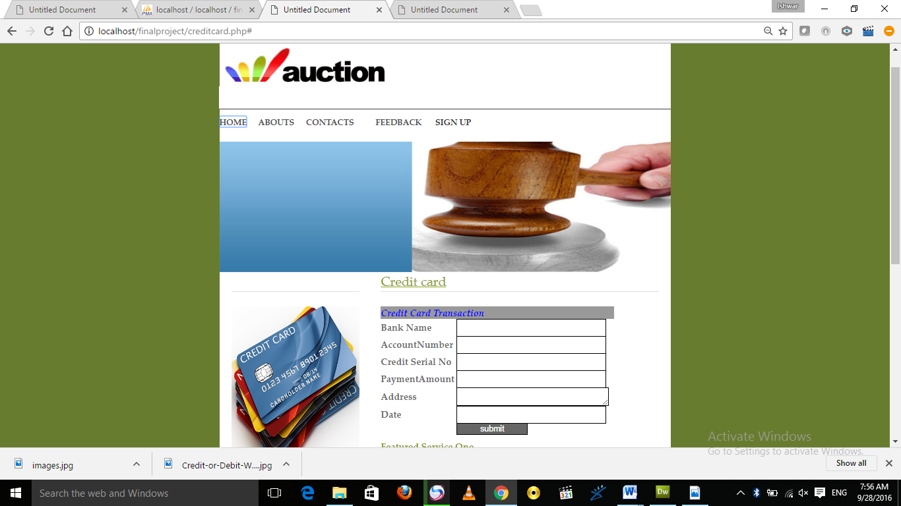

**Admin login:-**



**DESCRIPTION:-**

Our Admin Login detail display on Admin Login page

**Add Iteams:-**



**Add Auction Ditails :-**

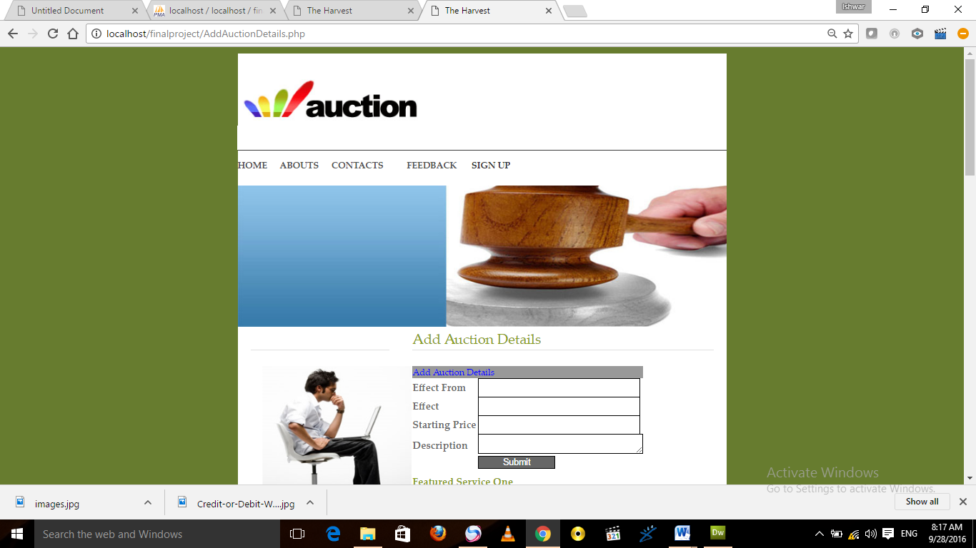

**DESCRIPTION:-**

Our Admin Add Auction detail.

**Feedback details-**



**DESCRIPTION:-**

User Freedback Distells page.

**Contact details:-**

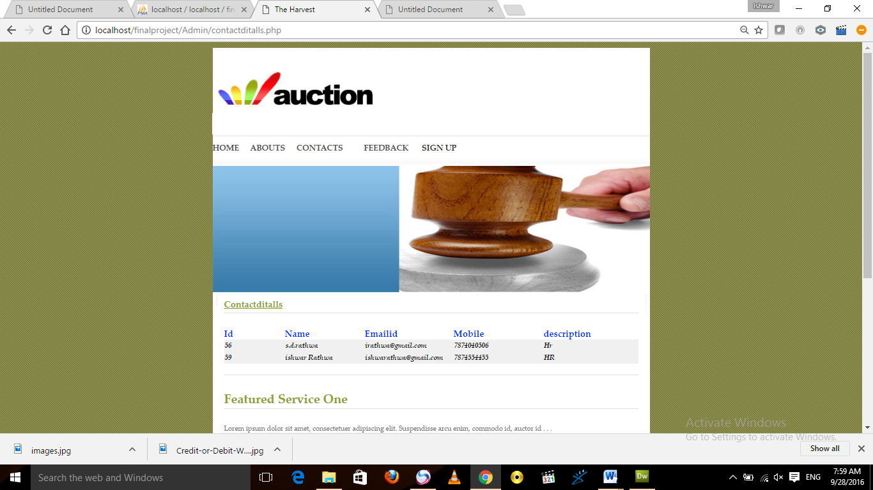

**DESCRIPTION:-**

User Contact Details page.

**LIMITATIONS & FUTURE ENHANCEMENT**

Chapter 5

**5.1 LIMITATIONS**

**5.2 FUTURE ENHANCEMENT**

­­

**5.1 LIMITATIONS:**

* All People Easy to manage Services..

**5.2 FUTURE ENHANCEMENT:**

* As a part of future enhancement a module for Services to people can be added to system.
* Other changes can be made according to People requirements.

**CONCLUSION**

Chapter 6

**5.1 CONCLUSION**

**6.1 CONCLUSION:**

This application software is user friendly, and has required options, which can be utilized by the user to perform the desired operations. The software is developed using ANGULAR AND SPRING BOOT as front end and Microsoft SQL server as back end in Windows environment. The goals that are achieved by the software are:

* Optimum utilization of resources.
* Efficient management of records.
* Simplification of the operations.
* Less processing time and getting required information.
* User friendly.
* Portable and flexible for further enhancement.

6.2

Bibliography and resources

<https://angular.io/tutorial>

<https://www.baeldung.com/spring-tutorial>

https://docs.spring.io/spring-framework/docs/3.0.x/spring-framework-reference/html/overview.html